# **Business Intelligence**

# **Lab 1**

# **Case study on Transaction Processing**

# **of**

# **RETAIL SALES**

## **KHUSHI AGARWAL**

## **Reg No. - 2248432**

### **Introduction:**

Let us consider a Retail store that is well-established and specializes in electronic gadgets, clothing, and furniture. With multiple physical stores and an active e-commerce platform, Retail stores generate a large volume of transactional data every day. The company recognizes the need to harness this data effectively to gain insights into customer behavior, optimize inventory management, and enhance overall operational efficiency. To achieve this, Retail stores decide to implement transactional processing for business intelligence in their retail operations.

### **Challenges:**

Retail stores face several challenges in utilizing transactional data for business intelligence:

1. Data Volume and Variety: The retail store generates vast amounts of transactional data, including sales records, customer details, inventory changes, and online orders. The data also comes in different formats and structures, making consolidation and analysis complex.

2. Real-time Reporting: Timely reporting and analytics are crucial for monitoring sales trends, tracking inventory levels, and making informed decisions to respond quickly to market changes.

3. Data Integration: The data comes from various sources, such as POS systems, e-commerce platforms, loyalty programs, and inventory management systems. Integrating this data seamlessly is vital for comprehensive analysis.

4. Customer Insights: Retail stores aims to understand customer preferences, buying patterns, and demographics to offer personalized experiences and improve customer satisfaction.

5. Competitive Edge: Leveraging transactional data to gain a competitive edge through data-driven strategies and targeted marketing initiatives is essential in the highly competitive retail industry.

### **Solution:**

To address these challenges, Retail stores adopt transactional processing for business intelligence, utilizing modern tools and technologies like Power BI.

#### STEP 1: Import the dataset to Power BI desktop

So for our Business Problem we have the dataset of a Retail Store which sells items like Electronics, Clothing and Furniture.

The 2 tables Order Details and Customer Details are connected by Order ID which is a Primary key in Order Details table and Foreign key in Customer Details.

The Order Details contains Columns: Order ID, Amount, Profit, Quantity, Category, Sub-Category, and Payment Mode for the Orders.

The Customer Details contains Columns: Customer Name, City, State, Order ID, Order Date.

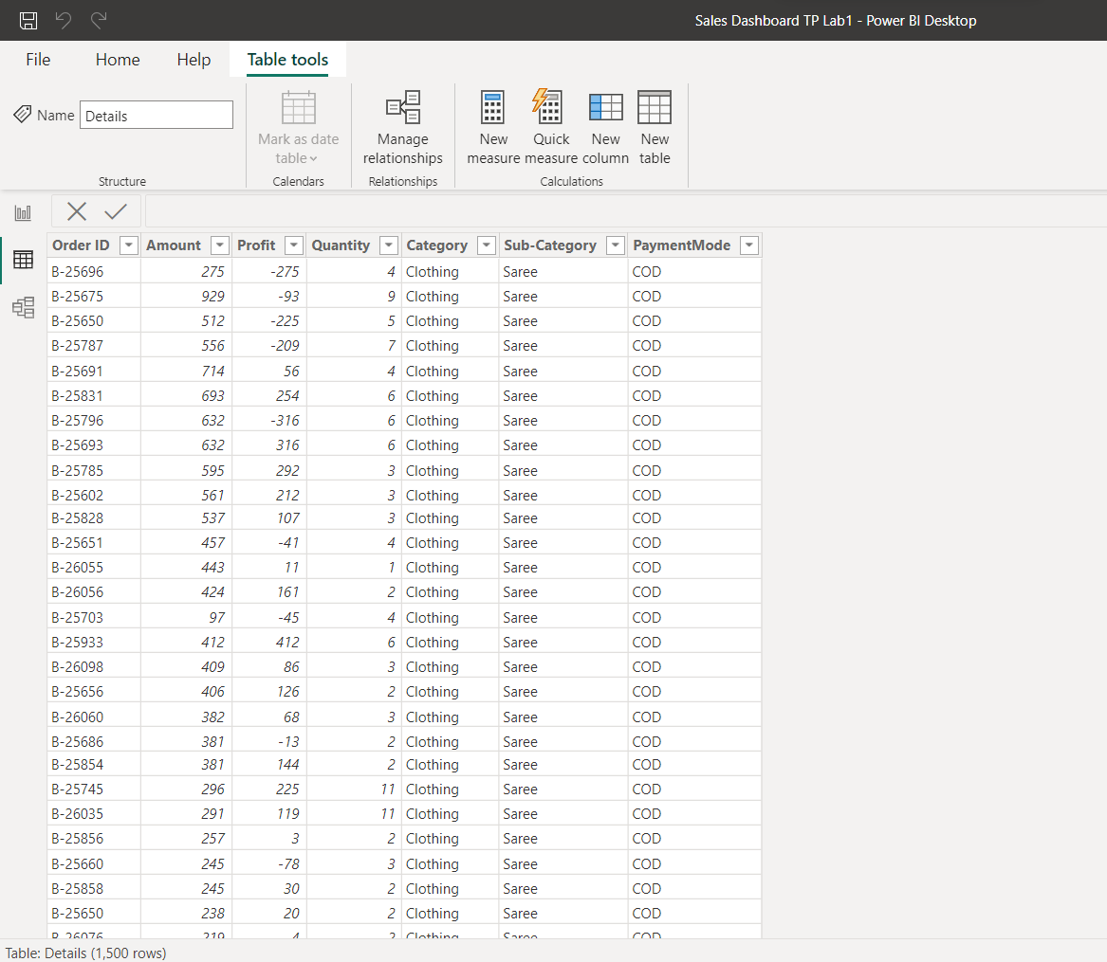

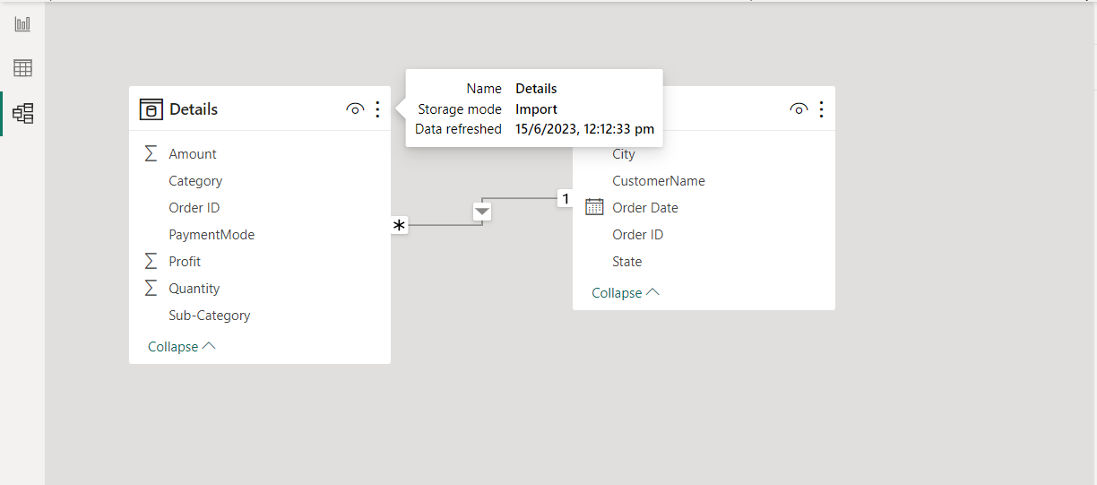

#### STEP 2: Calculate the Total Profit, Quantity, and Amount using CARD

Here we found that the Total Quantity of material with the retail store is 5615, Total Amount is 438000 and Total Profit obtained by the company is 37000.

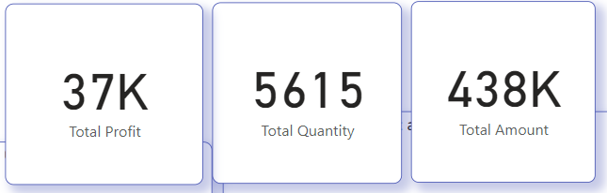

#### STEP 3: Plot Total Profit by Sub-Category using STACKED BAR

Here we plot the Total Profit generated by the Retail Store by Sub-category and Observe that Printers were the ones which gave the Retail Store it’s maximum profit then Bookcases and the third was Saree while T-shirt, Leggings, Skirt, Kurti, Electronic Games and Furnishing produced negative profit.

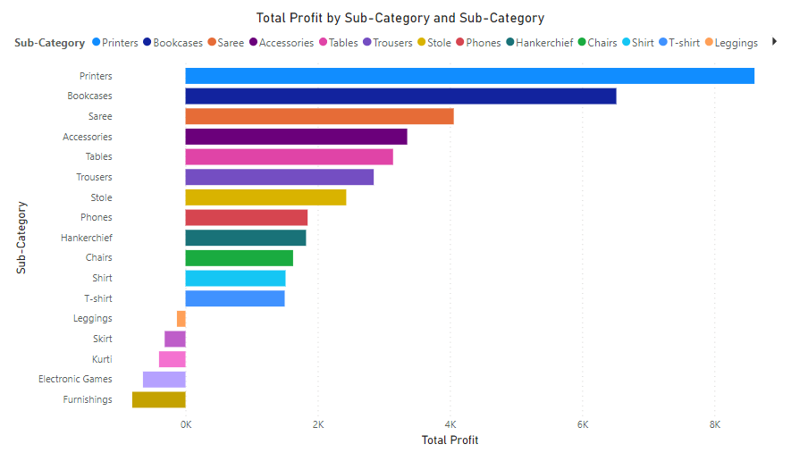

#### STEP 4: Plot Total Amount by Customer Name using STACKED BAR

Here we plot the Total Amount cost by the Retail Store by Customer Name and observe that Customer Harivansh has spent the most Amount purchasing stuff from this Retail store and is therefore a special customer whom we can offer deals to keep him from leaving.

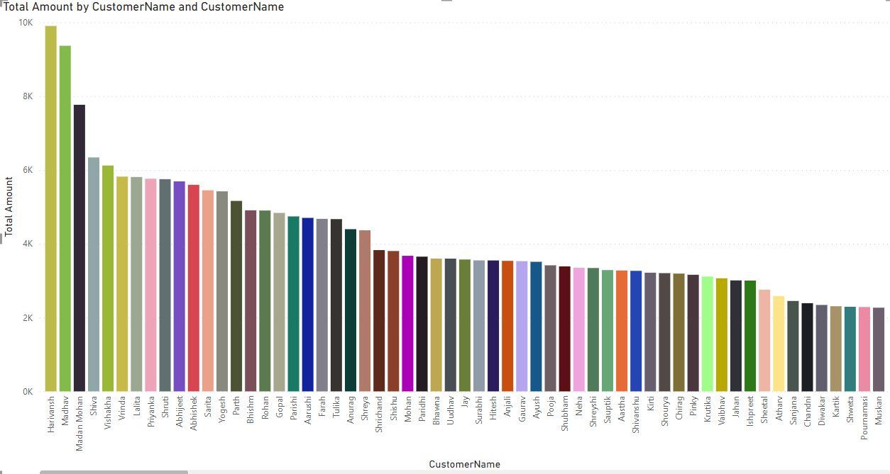

#### STEP 5: Plot Sum of Amount and Sum of Profit by State using STACKED BAR

Here we plot Sum of Amount and Sum of Profit by State and observe that Maharashtra had the most amount of Purchase and Profit. Next to Maharashtra is Madhya Pradesh, whereas Sikkim produced the least amount and profit. Rajasthan and Andhra Pradesh produced negative profit.

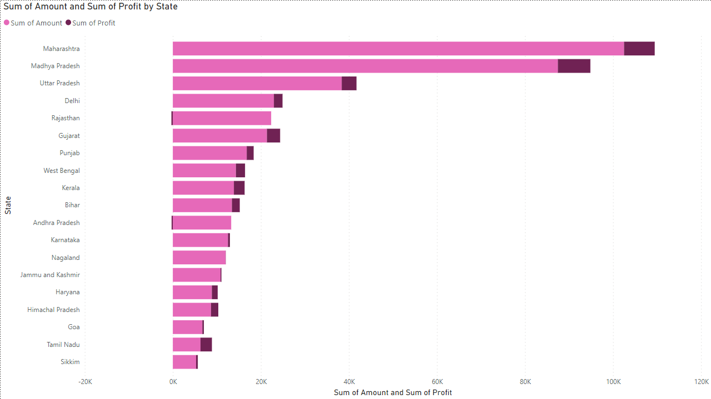

#### STEP 6: Plot Sum of Amount by Month using LINE CHART

Here we plot Sum of Amount by Month and observe that July had the lowest amount amd January and March highest amount.

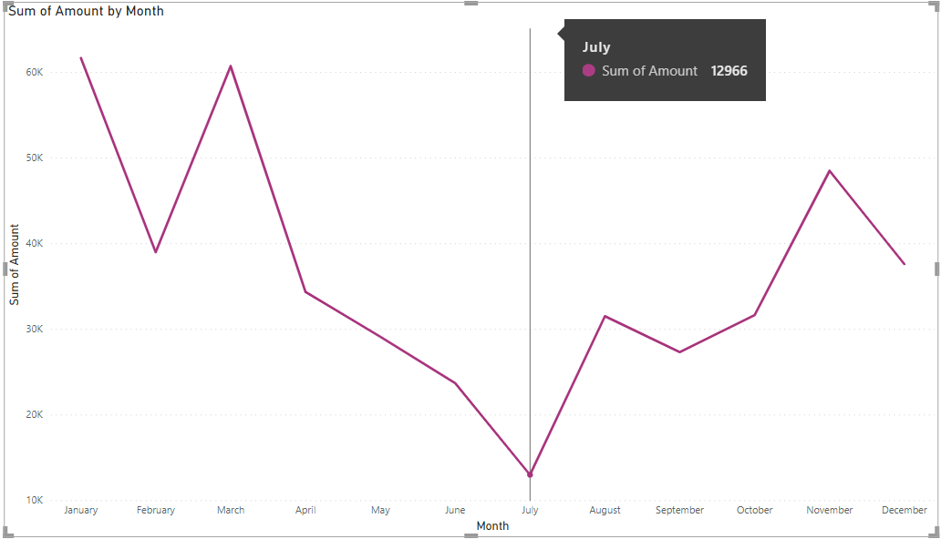

#### STEP 7: Plot Sum of Profit by Month using LINE CHART

Here we plot Sum of Profit by Month and observe that May had the lowest profit and January and November highest profit.

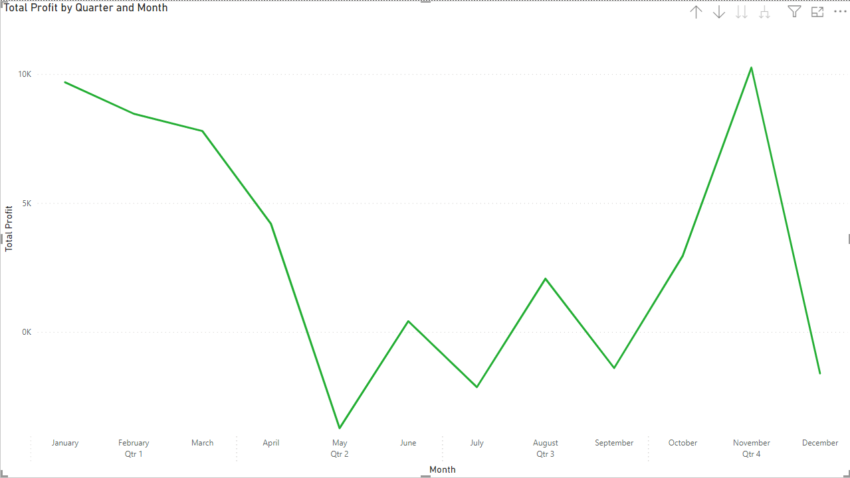

#### STEP 8: Plot Comparative Total Profit and Total amount by Month using LINE CHART

Here we plot Total Amount and Total Sum by Month and observe that February and November produced the highest profit than the amount and May and December produced the lowest. 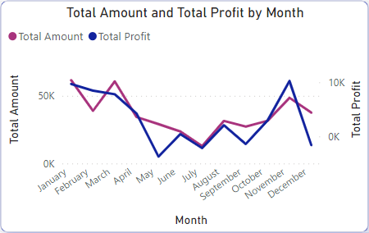

#### STEP 9: Plot Customer Name by State using FILLED MAP

Plot Customer Name by State to understand where our customers are from.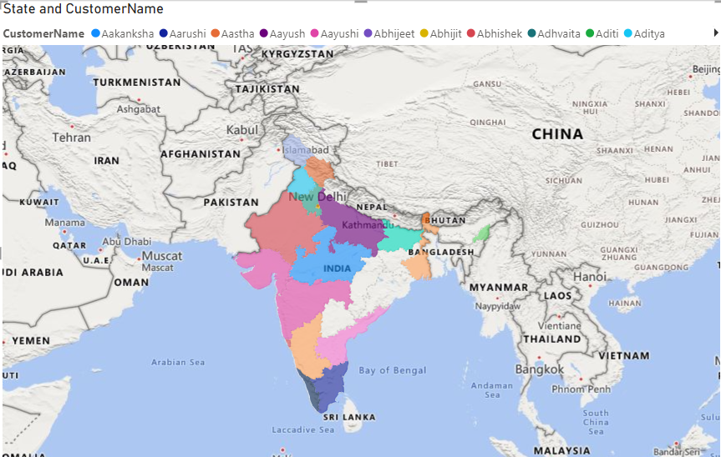

#### STEP 10: Plot Product Quantity by Category using DONUT CHART

Plot Product Quantity by Category to understand the percentage distribution of different types of products the retail store has. 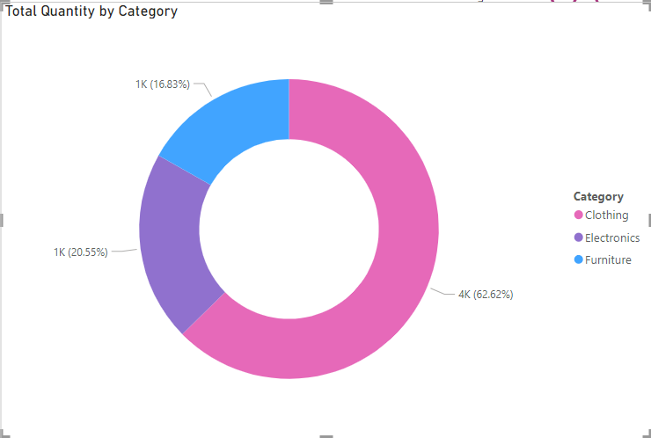

#### STEP 11: Plot Total Quantity by Payment Mode using PIE CHART

Plot Total Quantity by Payment Mode to understand the percentage distribution of different types of payment mode used by the customers.

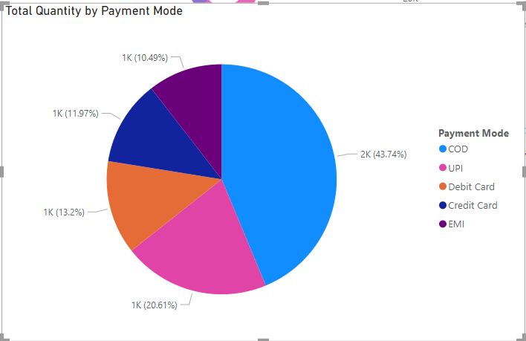

#### STEP 12: Plot Total Amount by Sub-Category using FUNNEL CHART

Plot Total Amount by Sub-Category we observe Printers were bought the most and Skirts the least. 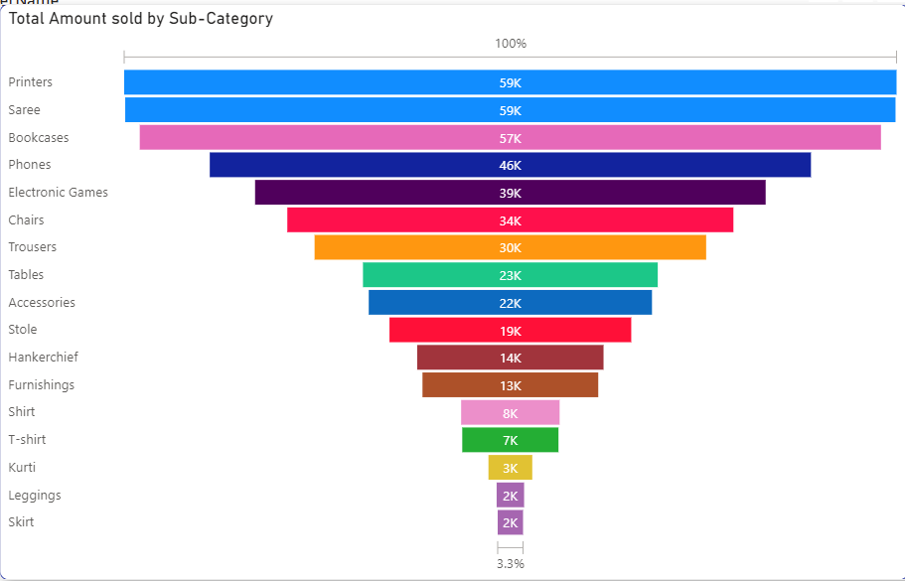

#### STEP 13: Our Final Dashboard is Ready!

It contains all the Analytics in one place.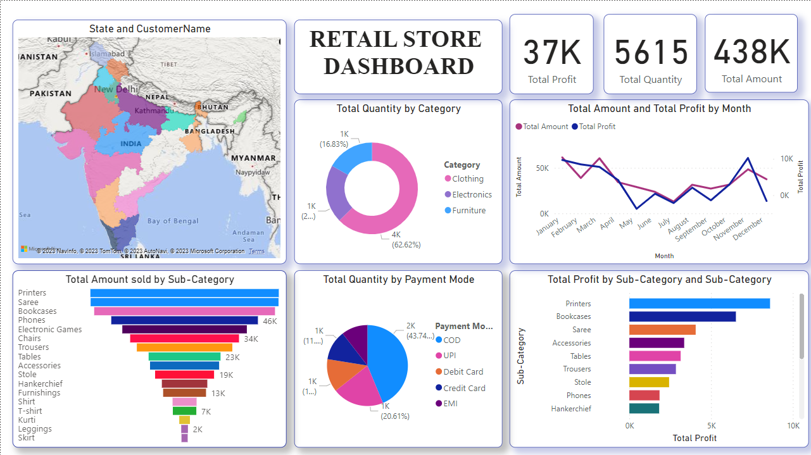

### **Benefits:**

The implementation of transactional processing for business intelligence brings Retail stores several benefits:

1. Improved Inventory Management: Real-time insights into inventory levels and customer demand enable Retail stores to maintain optimal stock levels, reducing carrying costs and avoiding stockouts.

2. Enhanced Customer Experience: Customer segmentation and personalized promotions lead to an improved shopping experience, fostering customer loyalty and repeat business.

3. Data-Driven Decision Making: Business intelligence empowers Retail stores' management team to make informed decisions, develop effective marketing strategies, and identify growth opportunities.

4. Competitive Advantage: Utilizing transactional data to gain a competitive edge enables Retail stores to stay ahead of competitors and respond swiftly to changing market dynamics.

5. Operational Efficiency: By analyzing transactional data, the retail store identifies process inefficiencies, leading to streamlined operations and cost savings.

### **Conclusion:**

With the implementation of transactional processing for business intelligence, Retail stores transform its transactional data into actionable insights that drive business growth and profitability. The ability to analyze real-time data, predict customer behavior, and optimize inventory management strengthens the retail store's position in the market. Leveraging modern tools and technologies, Retail stores remain at the forefront of the retail industry, providing exceptional customer experiences and making data-driven decisions that propel the business forward.